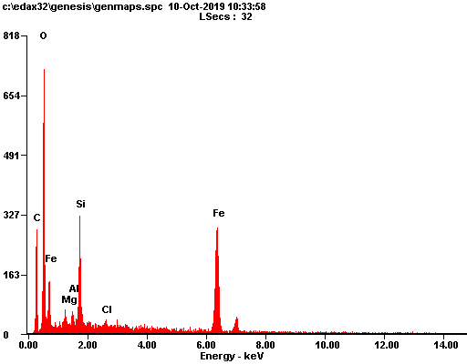

|  |  |  |
| --- | --- | --- |
| ***Element*** | ***Wt%*** | ***At%*** |
| ***CK*** | 17.54 | 36.28 |
| ***OK*** | 20.29 | 31.51 |
| ***MgK*** | 01.42 | 01.45 |
| ***AlK*** | 01.05 | 00.97 |
| ***SiK*** | 07.01 | 06.20 |
| ***ClK*** | 00.58 | 00.40 |
| ***FeK*** | 52.12 | 23.19 |
| ***Matrix*** | Correction | ZAF |

